OOP Concepts Explained in my Code

In my program, I found it easier to not use any method overloading or overriding, so that is nowhere in my code. I used an abstract class in constructing my Admin and Student Interfaces. I was able to implement the interfaces from the interface classes to assure all of the methods there were checked off. My Student Class and my Admin class both inherited from a User class. The only thing that was inherited from the User class was the username and password instance variables. Because I saw having no methods in the User as the easiest way to construct my program, there was also a lack of Polymorphism in my program. Inheritance and Abstract Class are shown in the figures below. 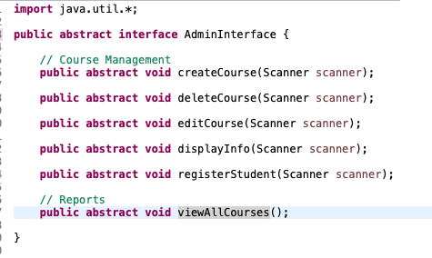Macintosh HD:Users:kaleballmon:Desktop:Screen Shot 2019-02-22 at 5.01.45 PM.png

In my program I added beyond the required methods and split up many actions I noticed I was going to be repeating into even smaller actions. The dozens of methods I have are an example of Encapsulation in my program and was hands-down the key for me to be able to construct my program as easy as possible. The only Abstract Data Type (ADT) I used in my program was an ArrayList.